Fabric Inventory Tool Prerequisites

Azure Subscription and Resource Group provisioned
- Key Vault
- Fabric Capacity (capacity size is adjustable)
- Service Principal created in Entra
- Security Group for assigning permissions (required. The Service Principal MUST be in this group)

Service Accounts and Apps

Azure Active Directory & Power BI Service

An AAD App (Service Principal) is used to authenticate calls to the Power BI API. The app is created through the Azure portal under App registrations.
Note that no Power BI API permissions should be granted through the Azure portal.
Power BI Admin API Permissions are granted in the Power BI portal through security groups. Therefore, once the AAD app is registered, the app needs to be added as a member to a new security group.
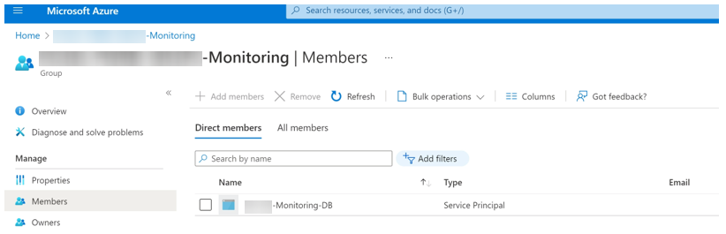
Power BI Admin API Permissions are granted through the PBI admin portal using the settings pictured below.
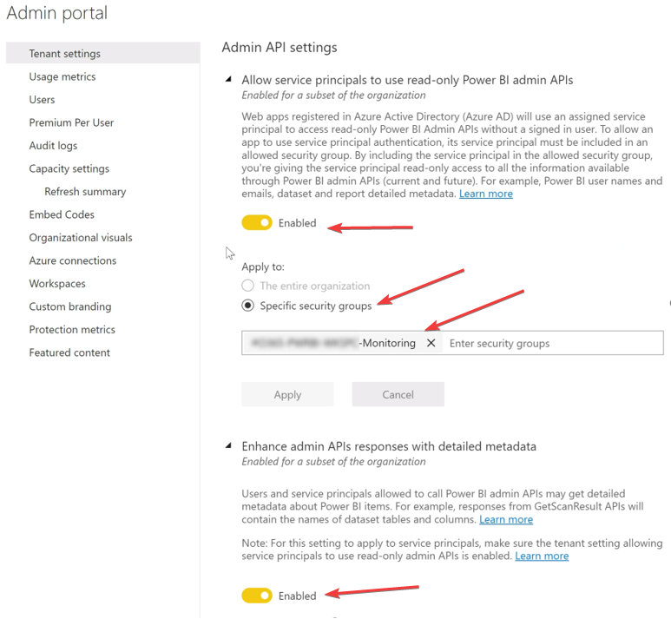

Key Vault

Key Vault
From within the Azure Portal, create a new key vault
(Replace the key vault name, the resource group, and the region with your desired info. If a key vault already exists, you can use it
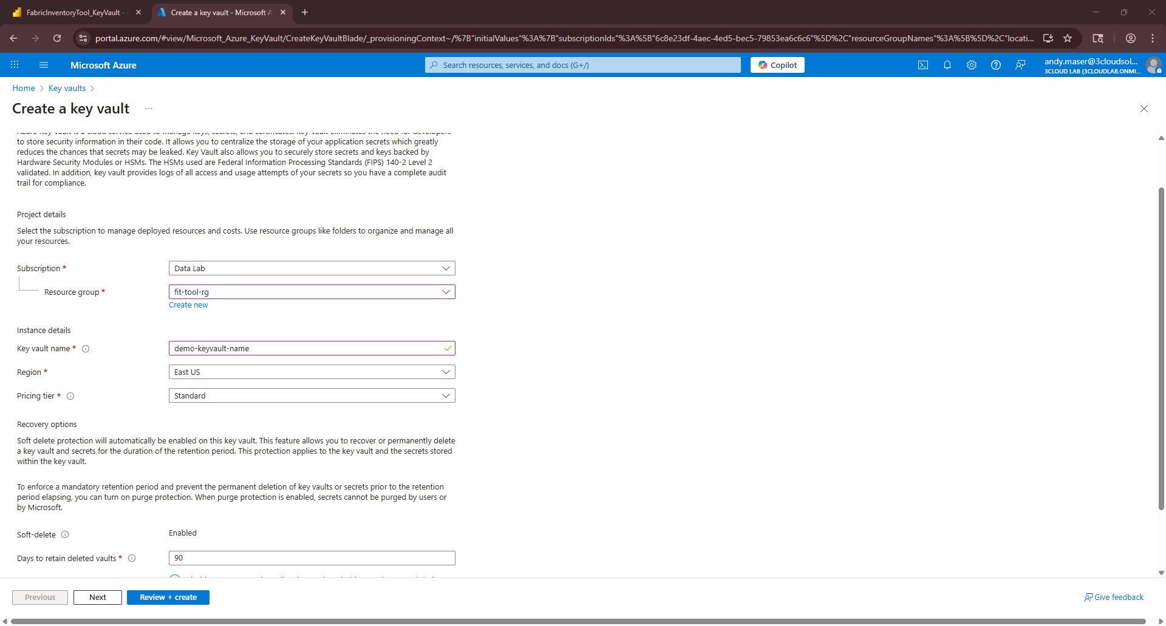
Make a note of the key vault url.

Grant, at a minimum, these 2 permissions to the Service Principal created earlier
You can set these under Access Policies from within the Key Vault.
(Note, you can also use RBAC permissions, key Key Vault Secret Reader permission) 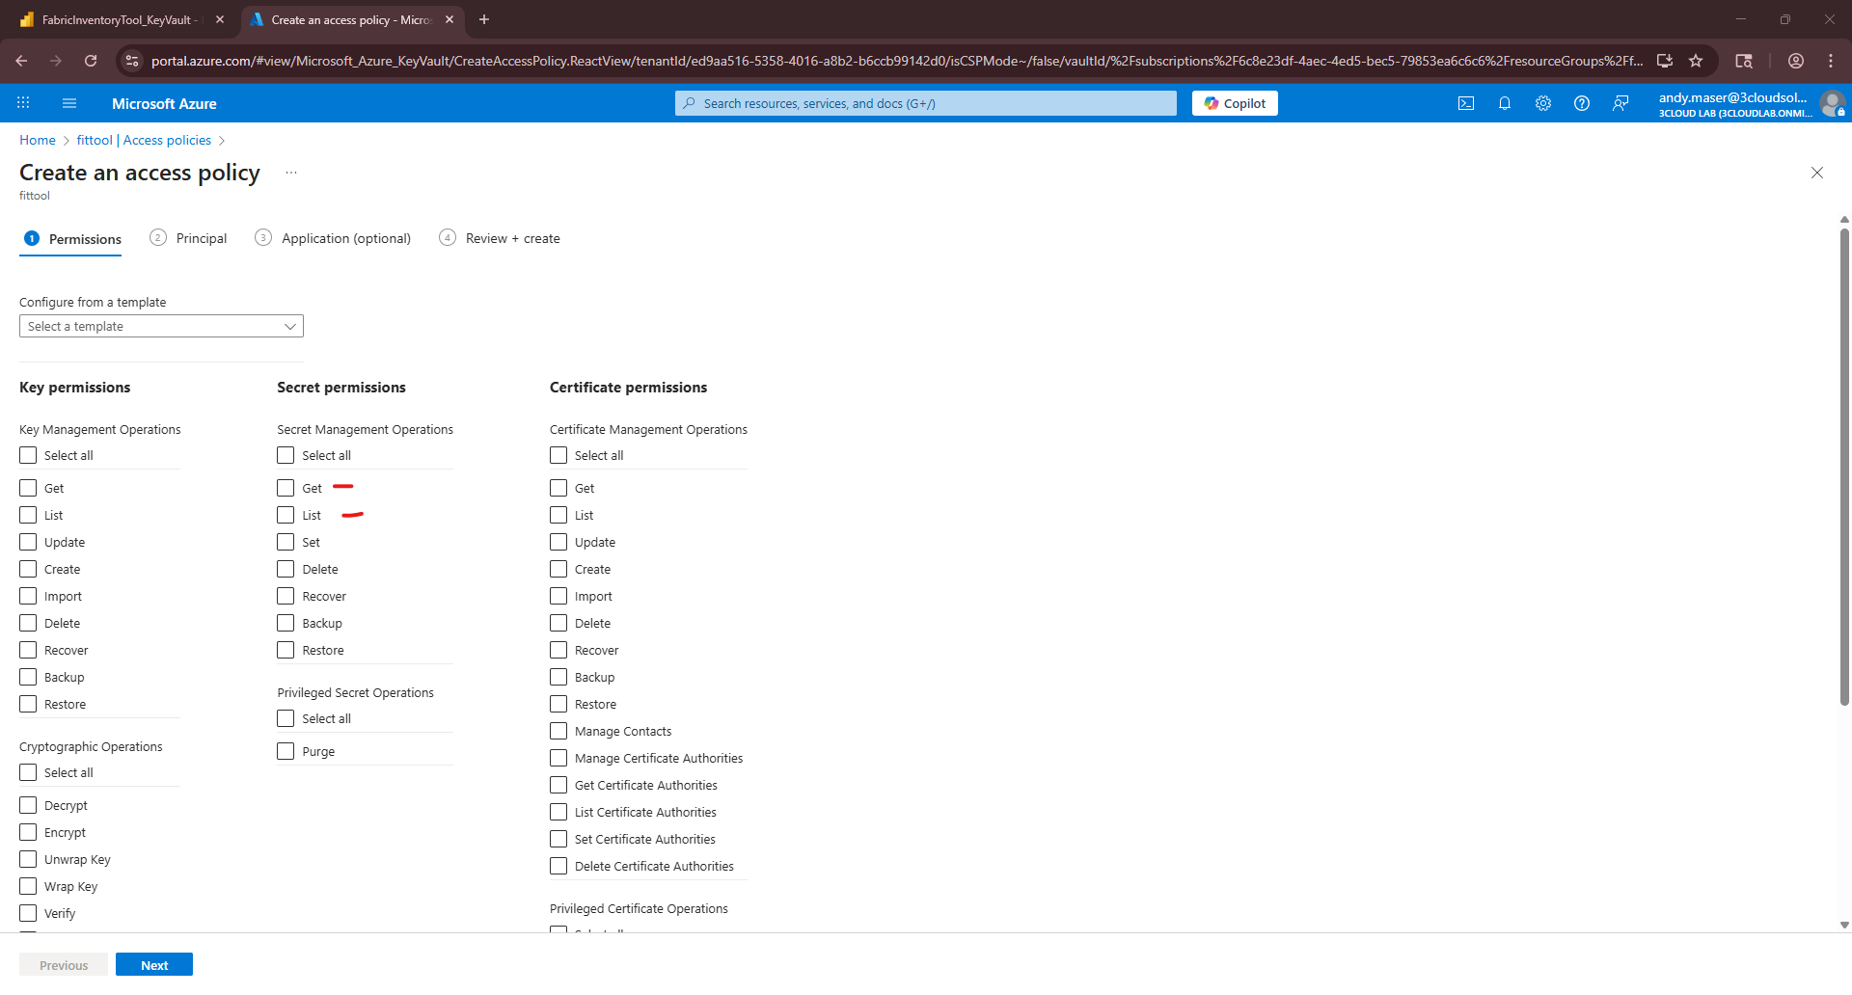

Within the keyvault, create 3 secrets (any name is fine, but make a note of the names)
one secret for tenant id, one for client id, and one for client secret
